# **AP Statistics- Tests of significance Review #1** NAME:________________________

**Inference learned so far:**

* 1 proportion z-test/interval - 1 sample t-test/interval (and paired test)
* 2 proportion z-test/interval - 2 sample t-test/interval
* Chi-Square goodness of fit test - Chi-Square test (homogeneity/independence)

1. The average weekly earnings for men in managerial and professional positions is $725. Do women in the same positions have average weekly earnings that are less than those for men? A random sample of 40 women in such positions showed =$670 and *s* = $102.



1. 2. Regardless of age, about 20% of American adults participate in fitness activities at least twice a week. However, the fitness activities in which people participate change as they get older, and occasional participants become nonparticipants as they age. In a local survey of 100 adults over 40 years of age, 15 people indicated that they participated in a fitness activity at least twice a week. Do these data indicate that the participation rate for adults over 40 years of age is significantly less than the 20% figure?



1. 3. “Looking Up to Athletes” (*USA Today*, May 7, 1991) reported “Here’s how sports team members say athletes do as role models for children: Excellent – 16%, Good – 38%, Fair – 41%, Poor – 5%.” Suppose you took a poll of 350 members within your community and obtained the following results (in the same order): 44, 145, 133, 28. Do your results show that your community has a significantly different idea about athletes as role models than the sports team members?

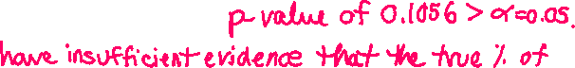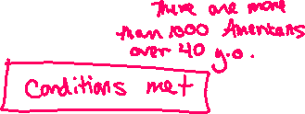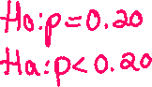

1. 4. An automobile manufacturer tries two distinct assembly procedures. In a sample of 350 cars coming off the line using the first procedure there are 28 with major defects, while a sample of 500 autos from the second line shows 32 with defects. Is the difference significant at the 10% significance level?

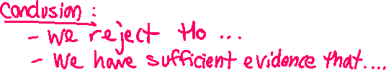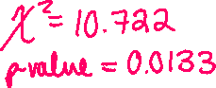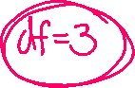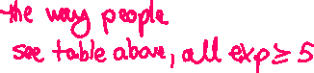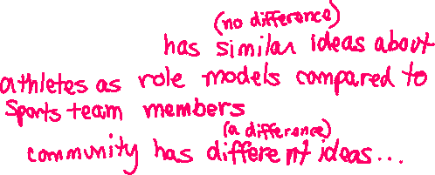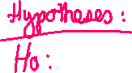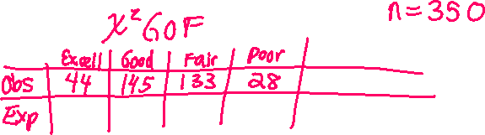

1. 5. A consumer agency is looking into the amount of water used by a new type of showerhead. They complete an experiment on a SRS of 50 showerheads where they run the showerhead for 20 minutes. If the sample mean is 22.8 gallons and the sample standard deviation is 2.6 gallons, estimate with 95% confidence the average amount of water used by the new showerhead during a 20 minute shower.

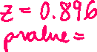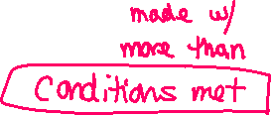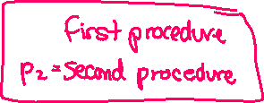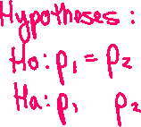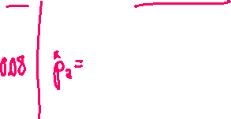

1. 6. A psychologist is investigating how a person reacts to a certain situation. He feels the reaction may be influenced by how ethnically pure the person’s neighborhood is. He collects data on 500 people. Does there appear to be a relationship between neighborhood and reaction at the 0.05 level of significance?

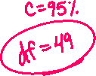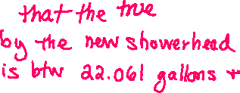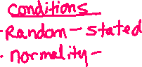

|  |  |  |  |
| --- | --- | --- | --- |
| **Pure?** | **Mild** | **Medium** | **Strong** |
| Yes | 170 | 100 | 30 |
| No | 70 | 100 | 30 |



|  |  |  |  |
| --- | --- | --- | --- |
| **Pure?** | **Mild** | **Medium** | **Strong** |
| Yes | 144 | 120 | 36 |
| No | 96 | 80 | 24 |

Ho: There appears to be NO relationship between neighborhood and reaction

Ha: There appears to be A relationship between neighborhood and reaction

Conditions:

* Random 🡪 assumed the 500 people surveyed are representative of all people
* Categorical data 🡪 Reaction and ethnic purity are categorical
* Expected counts 🡪 see table above, all expected counts > 5

Conditions met

X2 = 22.569

p-value = 1.256 x 10-5

We reject Ho because the p-value of is 1.256 x 10-5 < alpha = 0.05.

We have sufficient evidence that there appears to be A relationship between neighborhood and reaction.

1. A university investigation, conducted to determine whether car ownership affects academic achievement, was based on two random samples of 100 male students. The GPA for the 100 non-owners of cars had an average and std. deviation equal to 2.7 and 0.6, as opposed to an average and std. deviation of 2.54 and 0.6325 for the 100 car owners. Do the data provide sufficient evidence to indicate a difference in the mean achievement between car owners and non-owners?
2. We take a simple random sample of 95 Bucks county residents and find that only 20 of them approve of a new property tax to pay for repairs to local roads. Estimate with 99% confidence the true percent of people who approve of the tax.
3. The manager of an assembly process wants to determine whether the number of defective products manufactured depends on the day of the week the articles are produced. Using the data below, is there sufficient evidence to determine if the distribution of defective products is the same throughout the work week?

|  |  |  |  |  |  |
| --- | --- | --- | --- | --- | --- |
| **Day** | **Mon.** | **Tue.** | **Wed.** | **Thur.** | **Fri.** |
| Nondef. | 85 | 90 | 95 | 95 | 90 |
| Defective | 15 | 10 | 5 | 5 | 10 |

1. A random sample of 12 sixth graders was given a memory test. They were then enrolled in a 9-month chess program. At the end of the program they were given another memory test. The researchers were interested to see if learning chess would increase memory.  Complete a test.

|  |  |  |  |  |  |  |  |  |  |  |  |  |
| --- | --- | --- | --- | --- | --- | --- | --- | --- | --- | --- | --- | --- |
| **Student** | **1** | **2** | **3** | **4** | **5** | **6** | **7** | **8** | **9** | **10** | **11** | **12** |
| **Pretest** | 510 | 610 | 640 | 675 | 600 | 550 | 610 | 625 | 450 | 720 | 575 | 675 |
| **Posttest** | 850 | 790 | 850 | 775 | 700 | 775 | 700 | 850 | 690 | 775 | 540 | 680 |

1. Resting pulse rates for a random sample of 26 smokers had a mean of 80 beats per minute (bpm) and a

standard deviation of 5 bpm. Among 32 randomly chosen nonsmokers, the mean and standard deviation were 74 and 6 bpm. Both sets of data were roughly symmetric and had no outliers. Estimate with 90% confidence the difference between the average heart rate of smokers and non smokers.

1. Do men and women wear seatbelts the same % of the time? In order to find out, we take an SRS of 200 male drivers and another SRS of 250 female drivers. We find that there are 146 men that wear their seatbelts regularly and 203 women that wear them regularly. Estimate the difference between the % of men and women who wear seatbelts regularly using 98% confidence.